Experimental Design Options for MCPD Website

I’ve made quite a few changes to the design based on feedback from Wesley. This version of the website looks completely different, so I thought I’d make this document to help compare and contrast features with the original version. The changes are on the ‘wesleysFeedback’ branch of the GitHub repository.

# Original Homepage – Buttons and panels that stretch

Ignore the large margins, this was zoomed out to fit

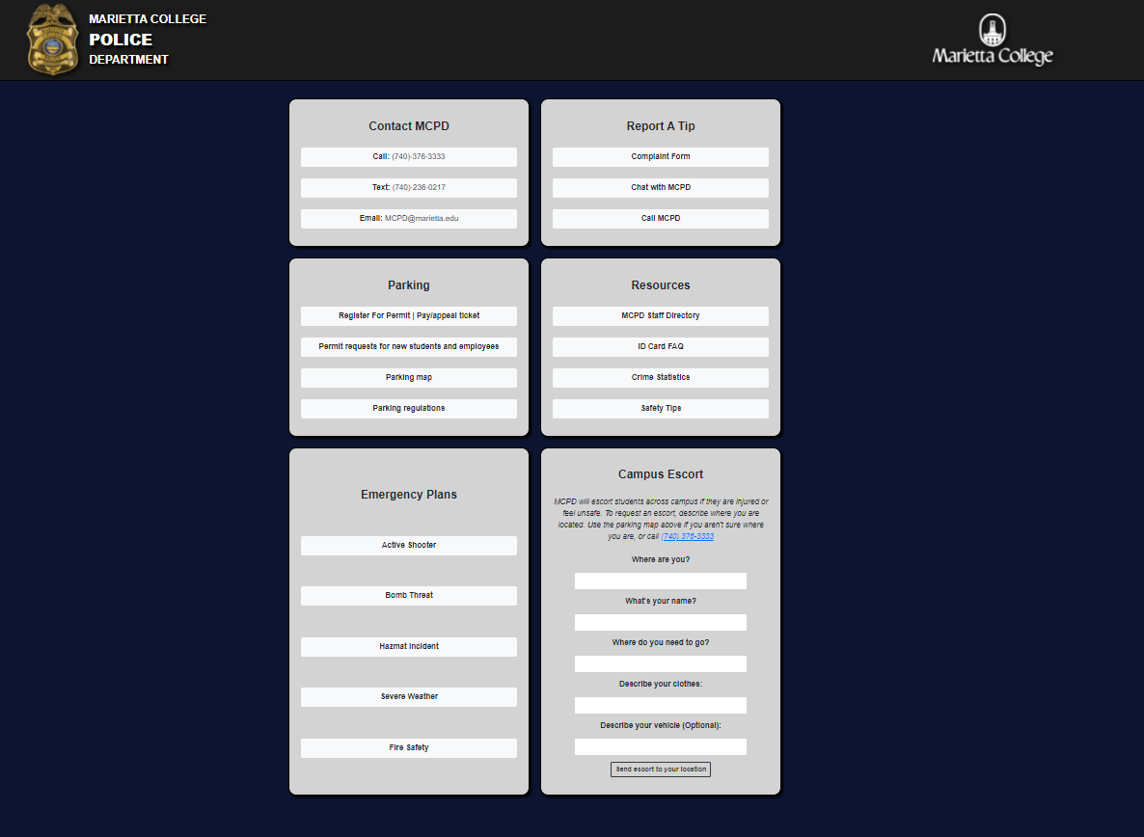

# Experimental Homepage Layout – List groups and fixed height panels

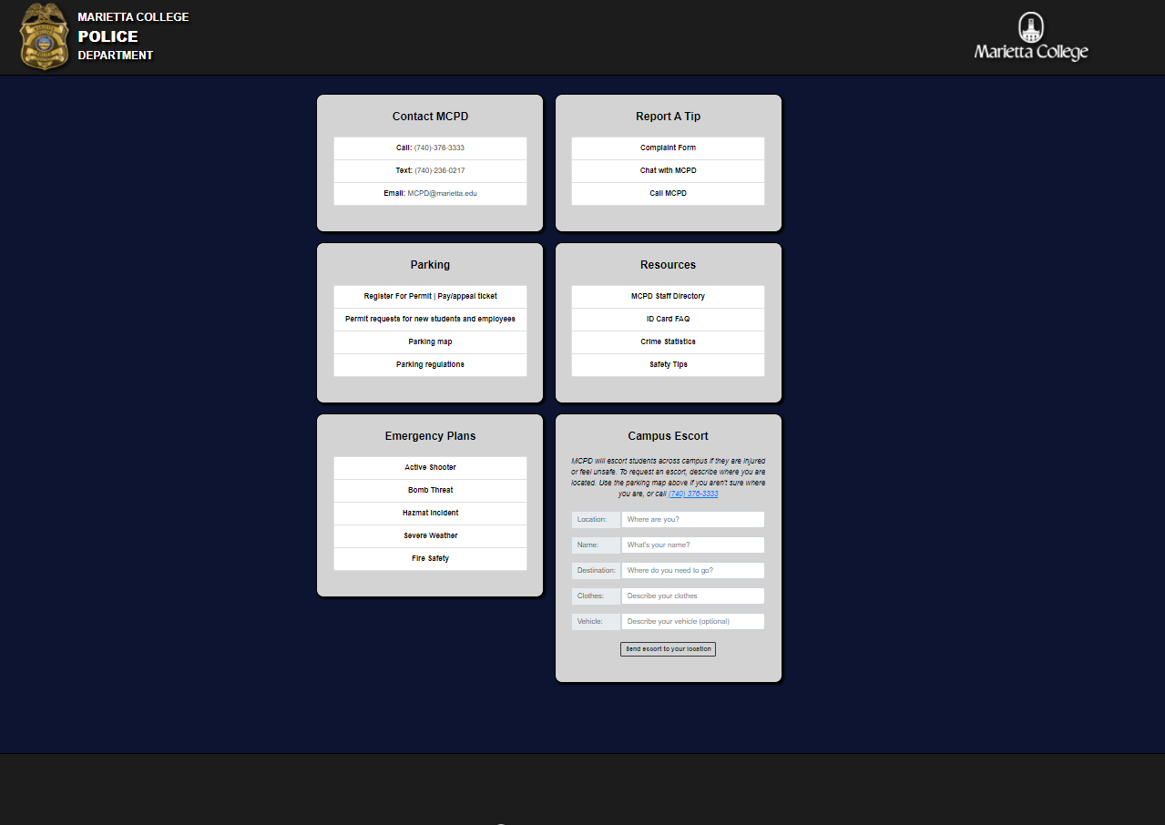

Wesley brought to my attention that the panels stretch to match the height of those on the same row when it’s in the two-column layout. This stretches the content of the emergency plans panel, e.g. from original:

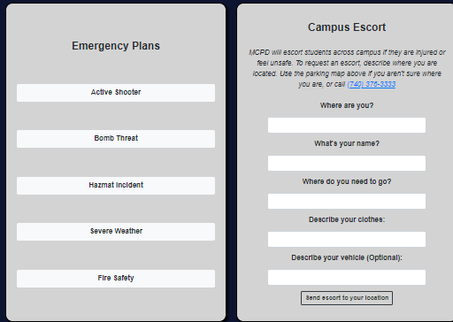

Versus when the panels are stacked in the original

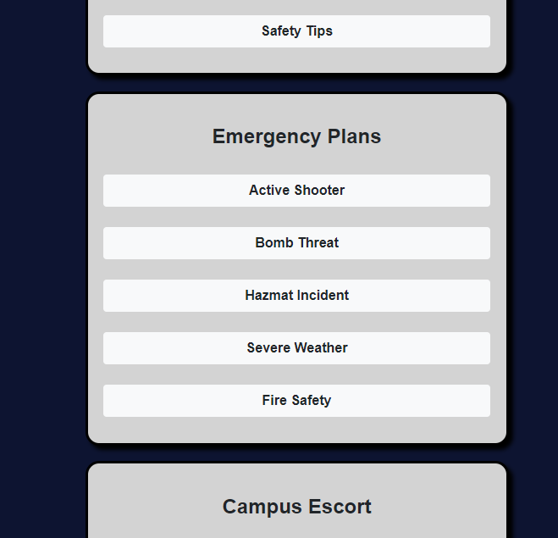

The new website locks the height of the columns to prevent this as seen previously. This prevents the stretching, but makes the webpage asymmetrical. Consider this tradeoff when deciding which layout you like. Here is what the original would look like with this:

# Original button style, but with fixed height panels

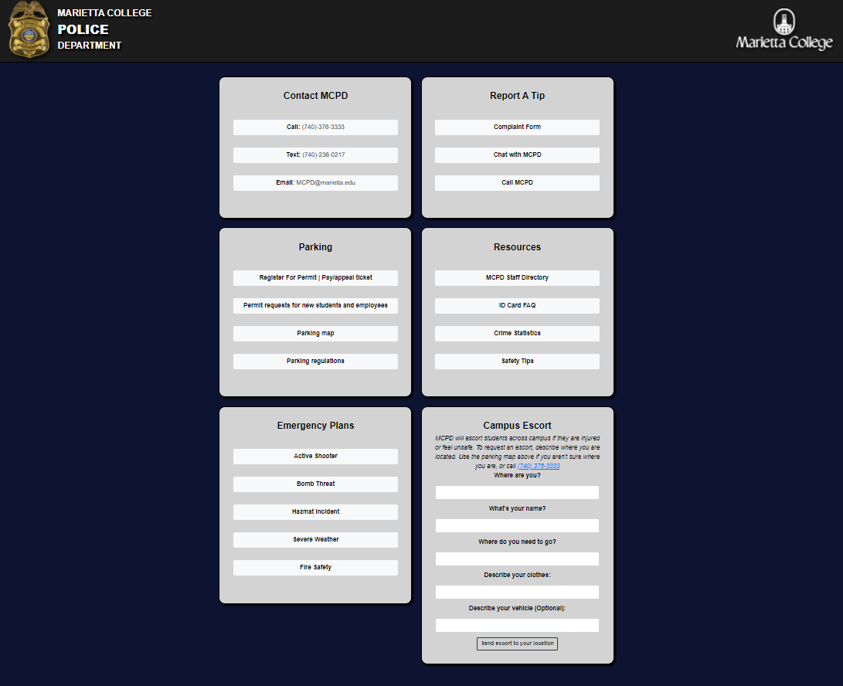

### List Groups instead of buttons

As you can see in the experimental version, the buttons are stacked on top of each other. This is because they are actually list groups and not buttons, which Wesley recommended that I try out. These are basically just buttons that look nice when you stack them on top of each other. You may prefer the spacing of the original buttons. Here is a comparison:

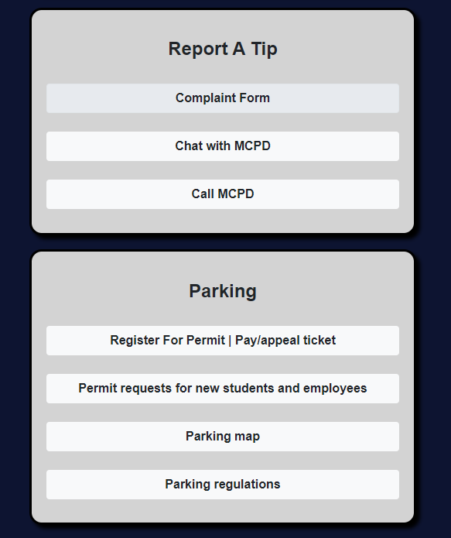 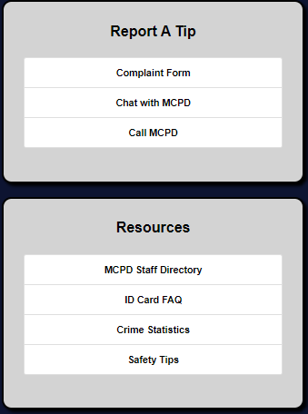

However, one thing to note about these is that I think they work well with left aligned text, and buttons don’t. Here is the page with left aligned text, with two panels set to buttons to show how each style looks:

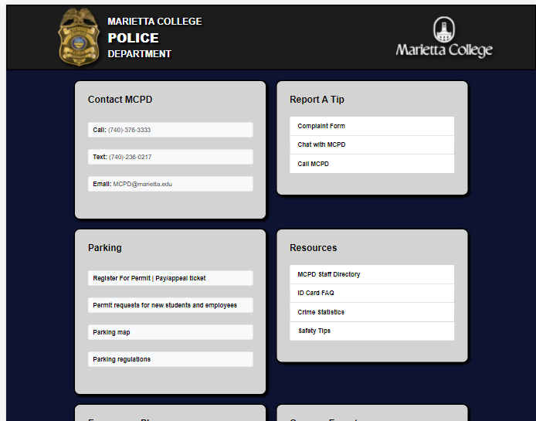

# Left Aligned Text

Wesley said he likes using left-aligned text because it’s easier to read. I think this could work for the MCPD home page, but I found it hard to make this look good. I think the list groups help though. Here is a left-aligned page using list groups:

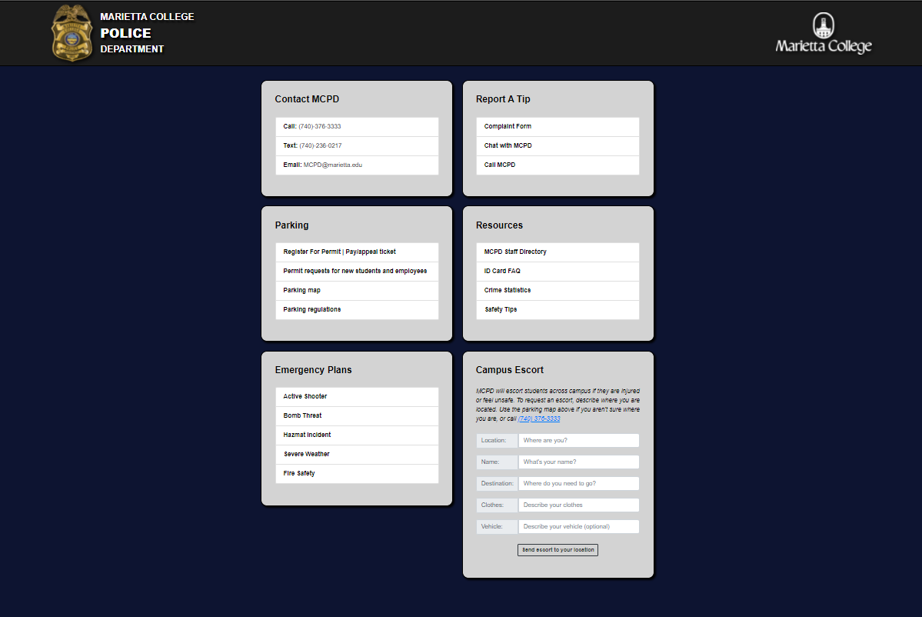

# Flush List Groups

Here is a version where the list groups are flush:

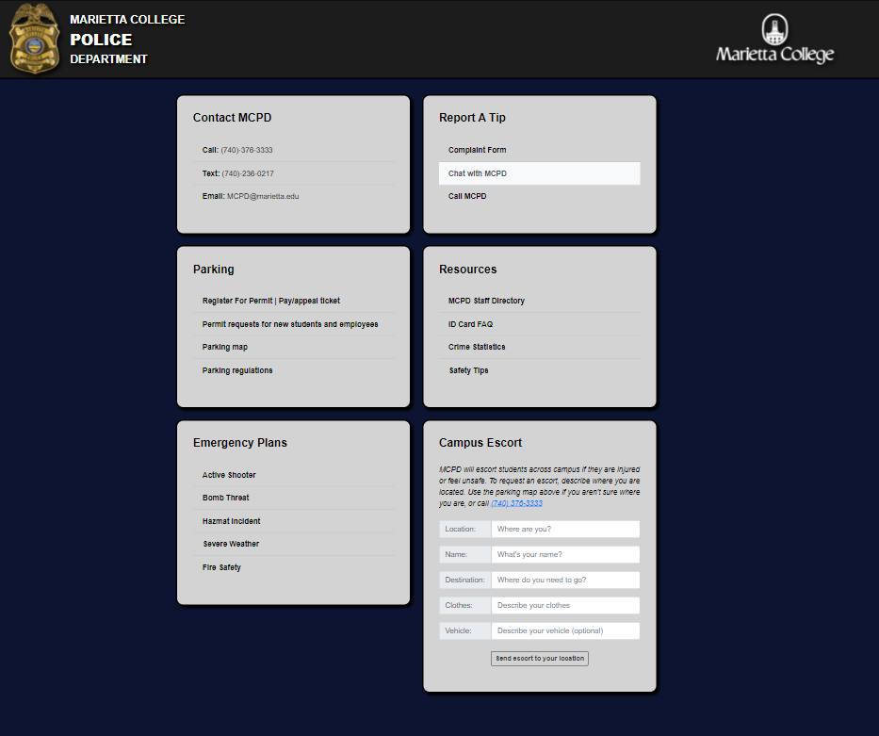

The chat with MCPD list item is selected to show how it looks when you click it. They also turn this color as you hover your mouse over each option.

Wesley also said centered text is ok for things like contact info. Here is how that looks:

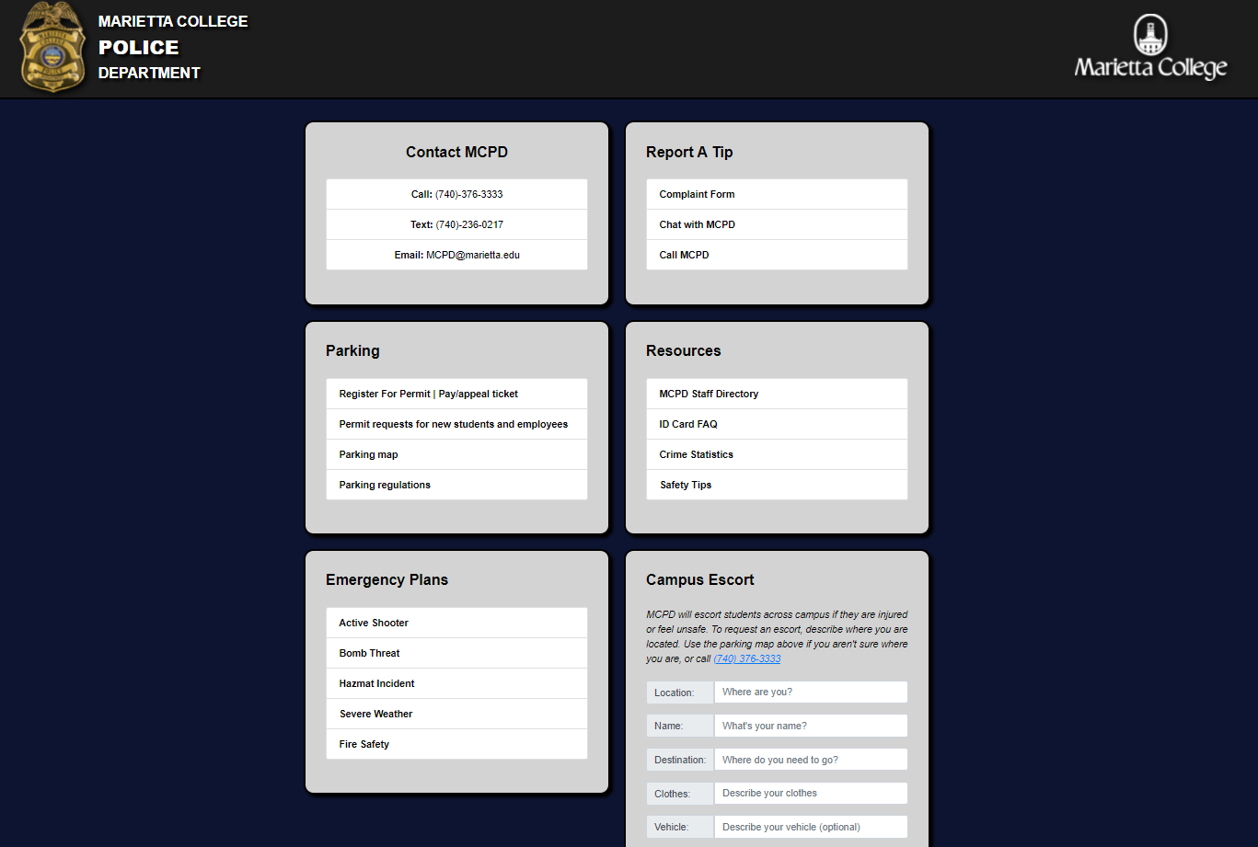

I think it looks misaligned when there are other panels that have left-aligned text next to it. I made it flush to give it more contrast:

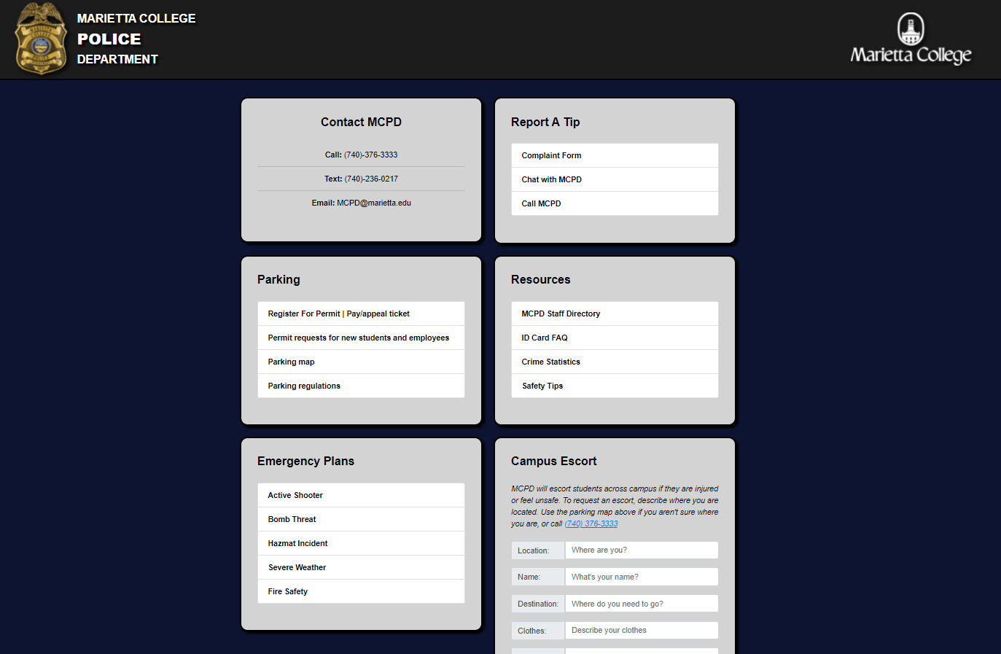

And here is the inverse with everything else flush:

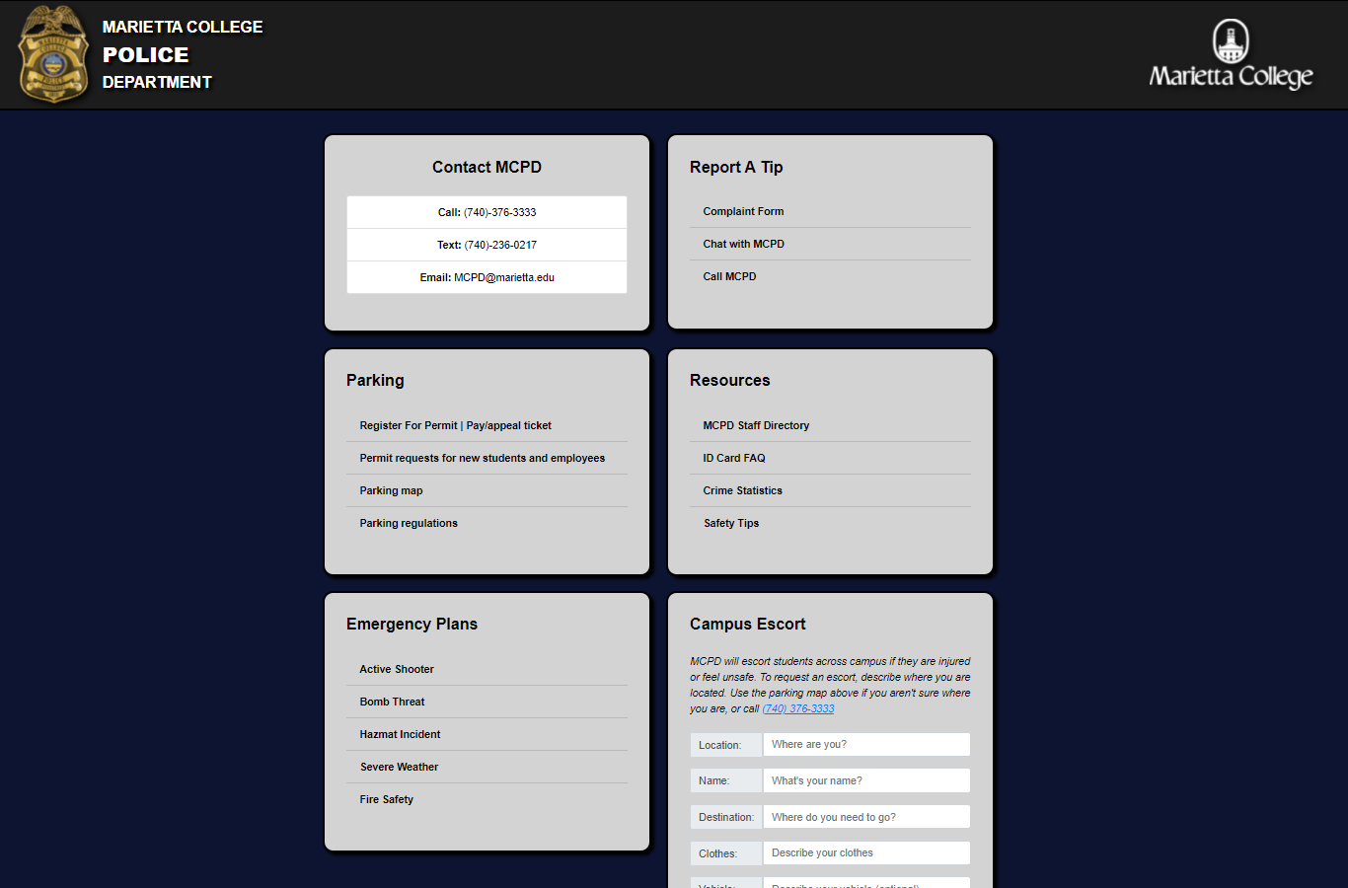

And without margin on the list group item text

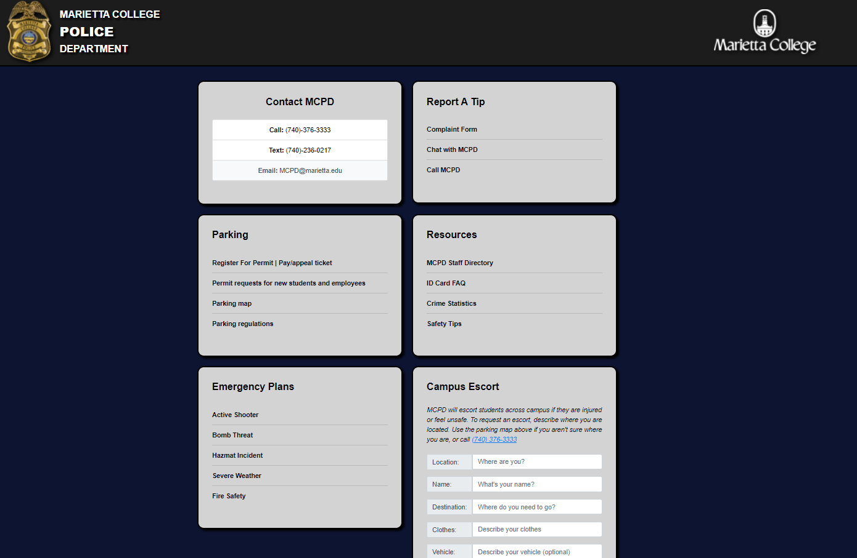

Let me know if you’re interested in any of these layouts using left-aligned text, or a combination of them.

# Original Escort Form

Here is how it looks in different sized windows.

### Mobile

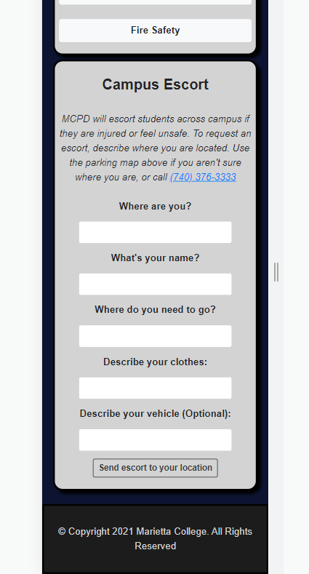

### Desktop Stacked

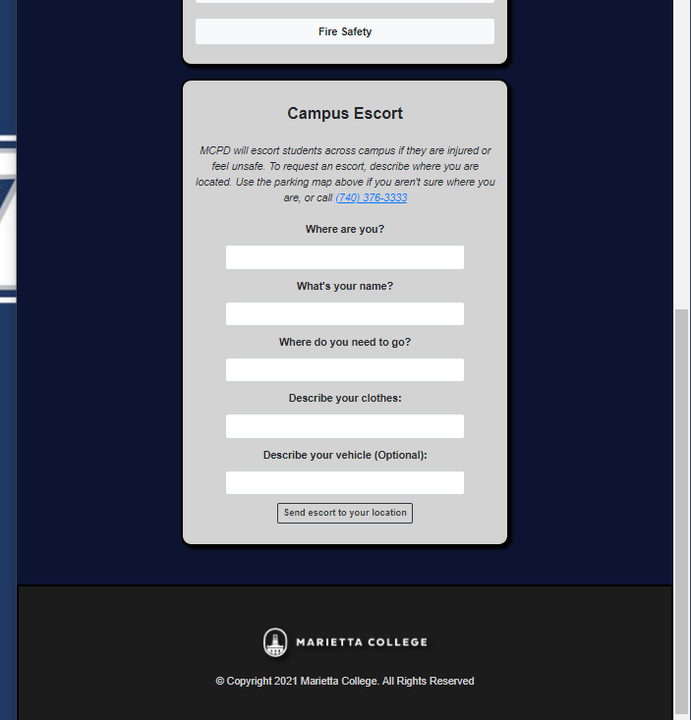

### Desktop Grid

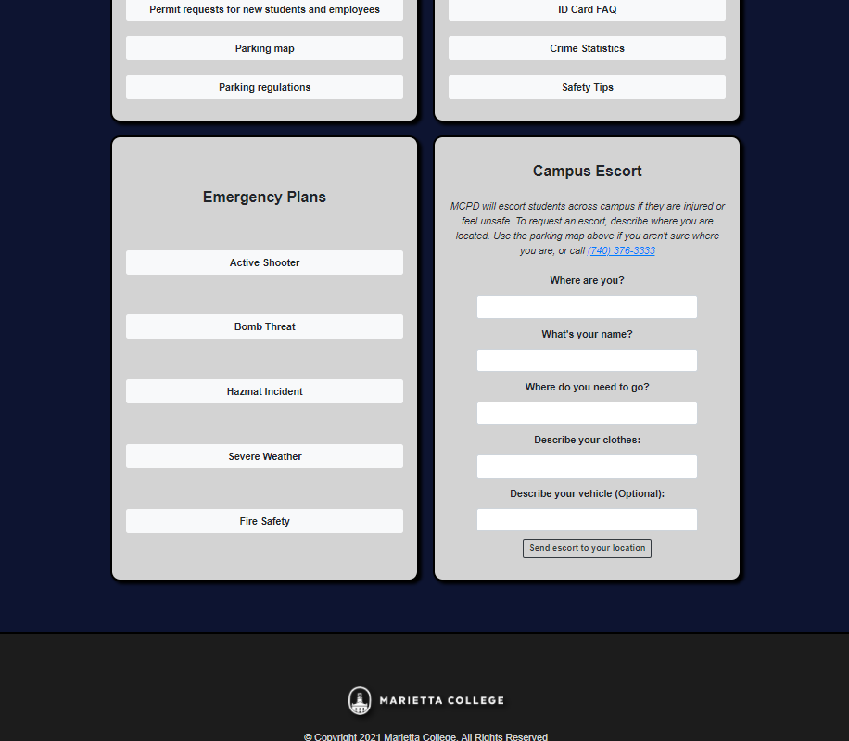

# New Escort Form

The new escort form uses bootstrap text inputs to combine the field and its label in one line. It behaves the same as the original when the window is resized.

### Equal Width Text Prepends, Centered Minimum Width Button

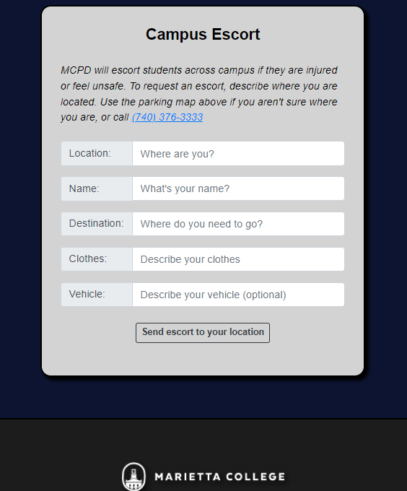

### With full width button

